King Fahd University of Petroleum and Minerals
College of Computer Science and Engineering
Information and Computer Science Department

ICS 253: Discrete Structures I
Summer Semester 2010-2011
Final Exam, Wednesday August 17, 2011.

Name:

ID#:

Instructions:
- This exam consists of nine pages, including this page, containing four questions.
- You have to answer all four questions.
- The exam is closed book and closed notes. No calculators or any helping aides are allowed. Make sure you turn off your mobile phone and keep it in your pocket if you have one.
- The questions are NOT equally weighed. Some questions count for more points than others.
- This exam is out of 150 points.
- You have exactly 120 minutes to finish the exam.
- Make sure your answers are readable.
- If there is no space on the front of the page, feel free to use the back of the page. Make sure you indicate this in order for me not to miss grading it.

Question Number | Maximum # of Points | Earned/Deducted Points
1 | 30
2 | 20
3 | 60
4 | 40
Total | 150

Some Useful Formulas:
$\sum_{i=1}^{n}{i}=\frac{n(n+1)}{2}$ , $\sum_{i=1}^{n}{i^{2}}=\frac{n(n+1)(2n+1)}{6}$ , $\sum_{i=1}^{n}{i^{3}}={\left(\frac{n\left(n+1\right)}{2}\right)}^{2}$ $\sum_{i=0}^{n}{a^{i}=\frac{a^{n+1}−1}{a−1} \text{where }a≠1}$ , $\text{log}\frac{a}{b}=\text{log}a−\text{log}b$ , ${\text{log}}_{b}a=\frac{\text{ln}a}{\text{ln}b}$

- (30 points) Choose the correct answer from the following choices. Note that the number of choices is not equal for all questions.
  - The number of strings of length 5 from decimal digits that have exactly three 9s is
    - 9²
    - P(5,3)×9²
    - C(5,3)×9²
    - 10²
    - none of the above.

  - The number of bit strings of length 12 that begin with 11 or end with 10 is
    - 2⁸
    - 2×2⁸
    - 2¹² – 2¹⁰
    - 2×2⁸ – 2¹⁰
    - none of the above.

  - The number of ways we can put 10 freshmen, 12 sophomores and 8 juniors in a line so that freshmen are first, the sophomores are in the middle and the juniors are at the end is
    - 10! × 12! × 8!
    - 30!
    - 10 × 12 × 8
    - 10! + 12! + 8!
    - none of the above.

  - A red and a green die are rolled. The probability of getting a sum of six given that the number on the green die is odd is
    - 3 / 36
    - 5 / 36
    - 6 / 36
    - 10 / 36
    - none of the above.

  - The sum 2 – 4 + 8 – 16 + 32 – … + 2²⁷ – 2²⁸ is
    - 2 + 2×2²⁹
    - 2 – 2×2²⁹
    - (2/3) + (2²⁹/3)
    - (2/3) – (2²⁹/3)
    - none of the above.

  - The function where is
    - one to one but not onto
    - onto but not one to one
    - one to one and onto
    - neither one to one nor onto

  - =
    - (– 1,1)
    - [-1,1]
    - {0}
    - Φ
    - none of the above.
  - Let S(x) be the predicate "x is a student," F(x) the predicate "x is a faculty member," and A(x, y) the predicate "x has asked y a question," where the domain consists of all people associated with your school. Then, the statement "Some student has never been asked a question by a faculty member" is represented by
    - none of the above.

  - The following two graphs are
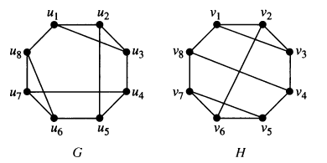
    - isomorphic
    - not isomorphic

  - The following graph is
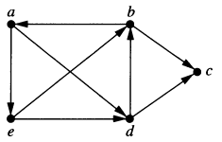
    - strongly connected
    - weakly connected with 4 connected components
    - weakly connected with 3 connected components
    - weakly connected with 2 connected components
    - not weakly connected.

- (20 points) Find the solution to the following recurrence relations defined for n ≥ 0
  - (10 points) a_{n} = 2a_{n – 1} – 3 , a₀ = – 1

  - (10 points) a_{n+2} = – 4a_{n+1} + 5a_{n} , a₀ = 2, a₁ = 8

- (60 points)
  - (45 points) For the following graph
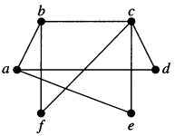
    - (10 points) Find an incidence matrix representation of G.

    - (7 points) Is G a bipartite graph? Prove your answer.

    - (7 points) Is G a planar graph? Prove your answer.

    - (7 points) Does G have an Euler circuit? Prove your answer.

    - (7 points) Does G have an Euler path? Prove your answer.

    - (7 points) Does G have a Hamilton circuit? Justify your answer.

  - (15 points) For the following graph, find the number of paths from vertex a to vertex e of length 4.
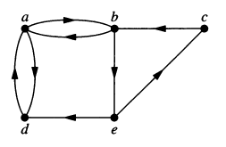

- (40 points) Trees
  - (10 points) Prove that the number of leaf vertices is one more than the number of internal vertices in a full binary tree.

  - (30 points) Answer the following questions regarding the logical expression
    - (7 points) Draw the ordered rooted tree representation of the logical expression above.

    - (5 points) What is the advantage of the prefix and postfix representations over the infix representation of logical expressions?

    - (9 points) Write the prefix representation of the above expression.

    - (9 points) Write the postfix representation of the above expression.

